Title
First Author¹ and Second Author^{2,*}
¹ University of Ngaoundere, P.O. Box 455, Ngaoundere-Cameroon
² MANAOO-JCI SARL, P.O. Box 88, Yaounde-Cameroon
* Corresponding author : info@lorexp.org

Abstract. The abstract should summarize the contents of the paper in short terms (200-300 words).
Keywords: First Keyword, Second Keyword, Third Keyword, Fourth Keyword, Fifth Keyword, Sixth Keyword.

1. First Section
1.1. A Subsection Sample
Please note that all the paragraphs of a section or subsection are not indented. The first paragraphs that follows a table, figure, equation etc. does not have an indent, either.
Sample Heading (Third Level). Only two levels of headings should be numbered. Lower level headings remain unnumbered; they are formatted as run-in headings.
Sample Heading (Forth Level). The contribution should contain no more than four levels of headings. The following Table 1 gives a summary of all heading levels.
Table 1. Table captions should be placed above the tables.
Heading level | Example | Font size and style
Title (centered) | Lecture Notes | 14 point, bold
1st-level heading | 1. Introduction | 12 point, bold
2nd-level heading | 2.1. Printing Area | 10 point, bold
3rd-level heading | Run-in Heading in Bold. Text follows | 10 point, bold
4th-level heading | Lowest Level Heading. Text follows | 10 point, italic

Displayed equations are centered and set on a separate line.
x + y = z (1)

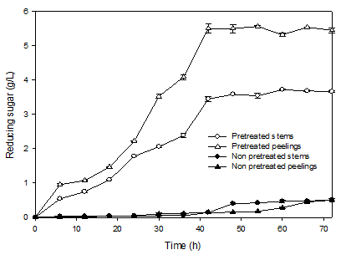
Fig. 1. A figure caption is always placed below the illustration. Short captions are centered, while long ones are justified.

For citations of references, we prefer the use of square brackets and consecutive numbers. Citations using labels or the author/year convention are also acceptable. In all cases, adopt the same writing design from one reference to another.

References (an example for an article and a book)
Author, B., Article title. Journal 2(5), 99–110 (2016).
Author, B., Author, A., Author, Z., Book title. 2nd edn. Publisher, Location (2005).

